# Team Foundation Server Plug-in for Eclipse

**May, 2017**

**INFOSYS LIMITED**

**Bangalore**

|  |  |  |  |
| --- | --- | --- | --- |
| Document No. | NA | Ver. Rev. : | 0.1 |
| Authorized by: | NA | Signature/:  Date: | Drishti Srivastava  04-05-2017 |

**COPYRIGHT NOTICE**

©2014 Infosys Limited, Bangalore, India. All rights reserved. Infosys believes the information in this document is accurate as of its publication date; such information is subject to change without notice. Infosys acknowledges the proprietary rights of other companies to the trademarks, product names and such other intellectual property rights mentioned in this document. Except as expressly permitted, neither this document nor any part of it may be reproduced, stored in a retrieval system, or transmitted in any form or by any means, electronic, mechanical, printing, photocopying, recording or otherwise, without the prior permission of Infosys Limited and/or any named intellectual property rights holders under this document.

Infosys Limited

Hosur Road

Electronic City, 3rd Cross

Bangalore 560 100

India.

**Author(s): Drishti Srivastava**

**Date written (MM/DD/YY): 05/04/17**

**Target readers Automation** **Testers**

**Keywords**

TFS, TFS plugin, Selenium

# Introduction:-

This document helps the user in installing TFS plugin for Selenium which helps in Version Control of the automation scripts.

# Steps for Installing TFS Plugin for Selenium

## Prerequisites:-

* Copy and extract the below mentioned file from LAN to your Local

\\Ad.infosys.com\storage\BLR\KEC\BPO\1500T1\Work\Testing\New LAN Structure\14. Automation\Selenium Setup\TFSEclipsePlugin-UpdateSiteArchive-14.0.3.zip

To install the plug-in

1. Open Eclipse.
2. On the **Help** menu, choose **Install New Software**.

The **Install** dialog box appears.

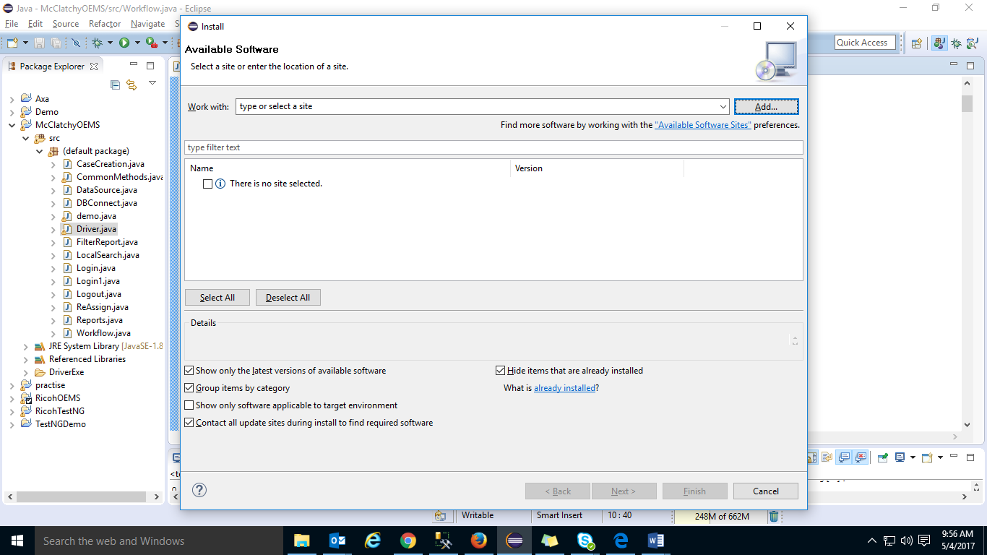

1. Choose Add. The Add Repository dialog box appears. Click on Local Tab

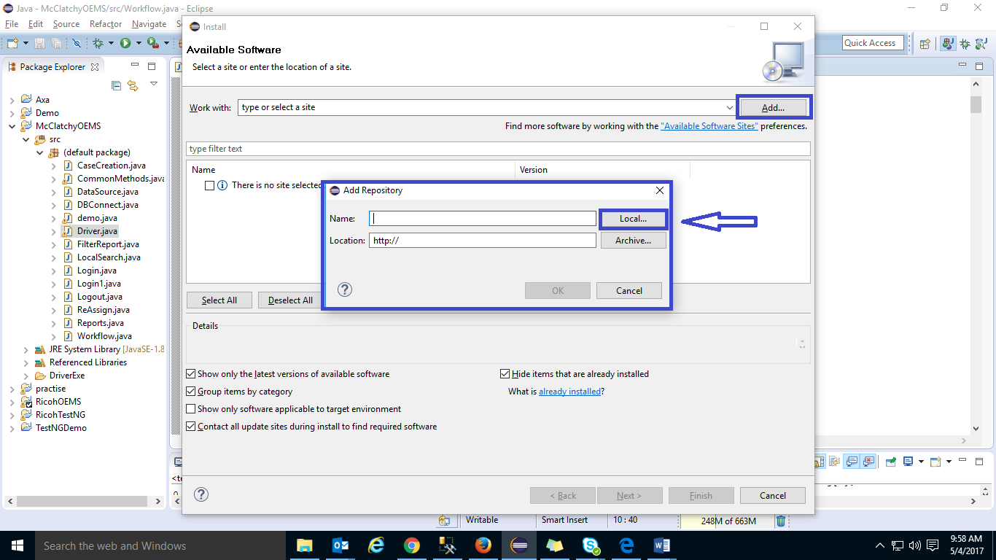

1. Navigate to the copied folder from the LAN and click on OK

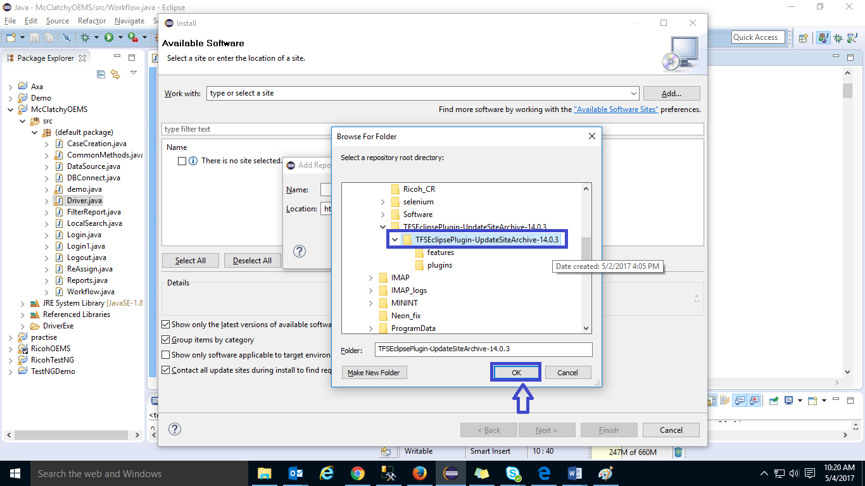

1. In Name, enter TFS and click on “OK”

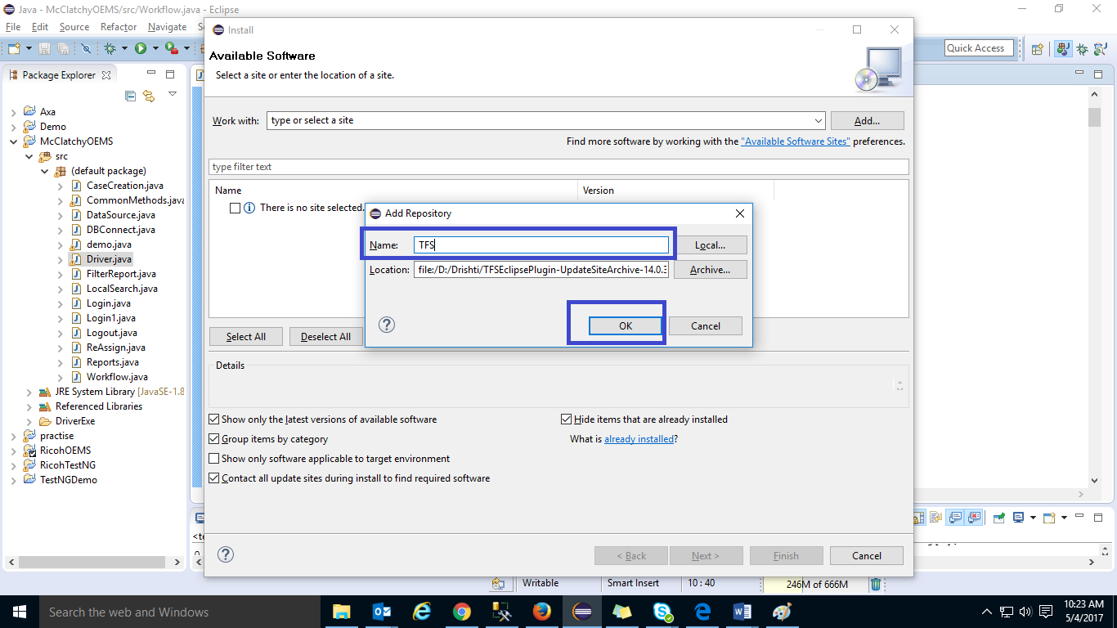

1. In the list of features in the Install dialog box, select the check box that corresponds to Team Explorer Everywhere, and then choose **Next** two times and then click on Finish.

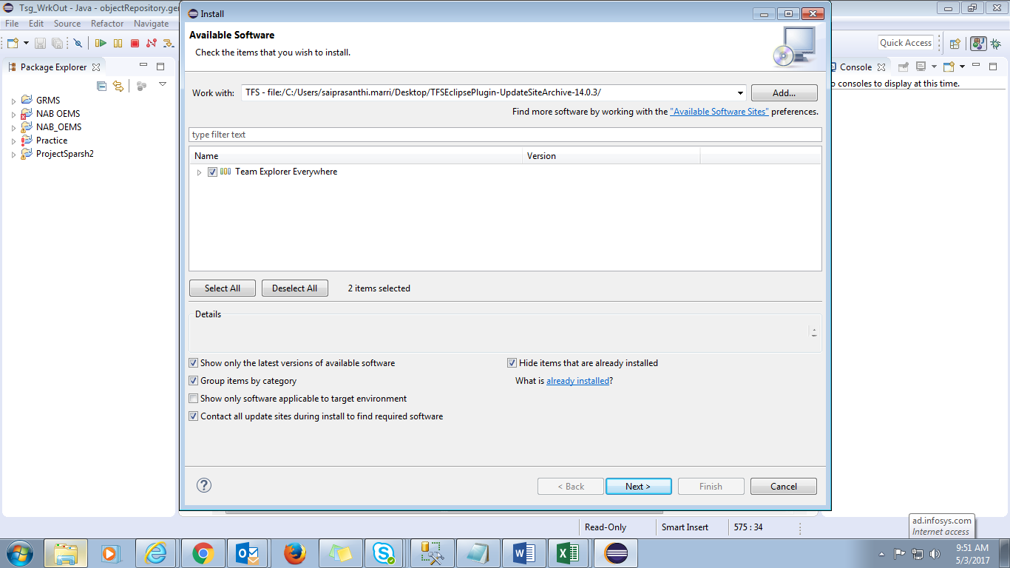

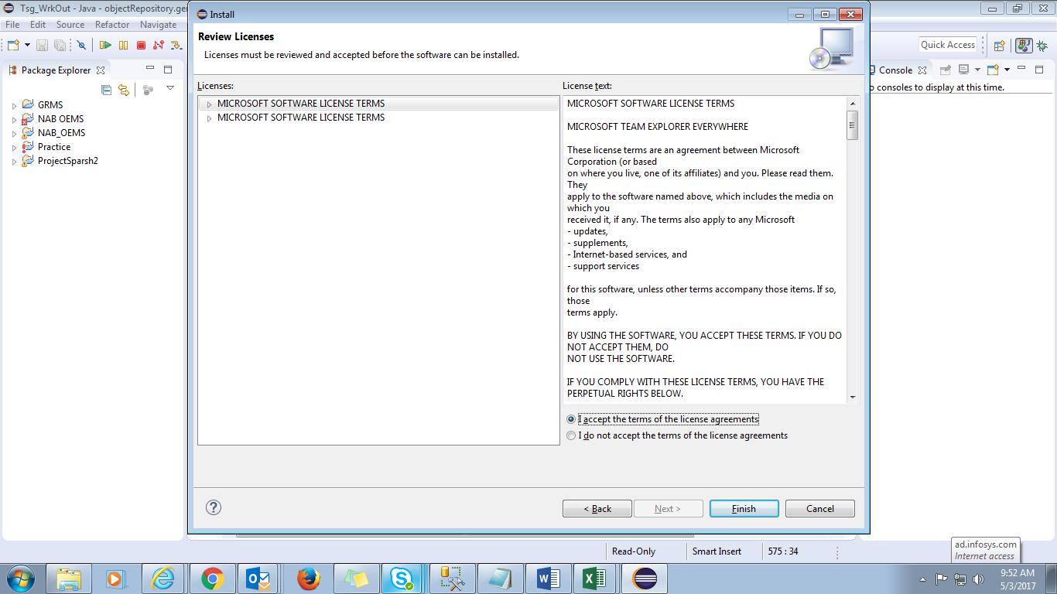

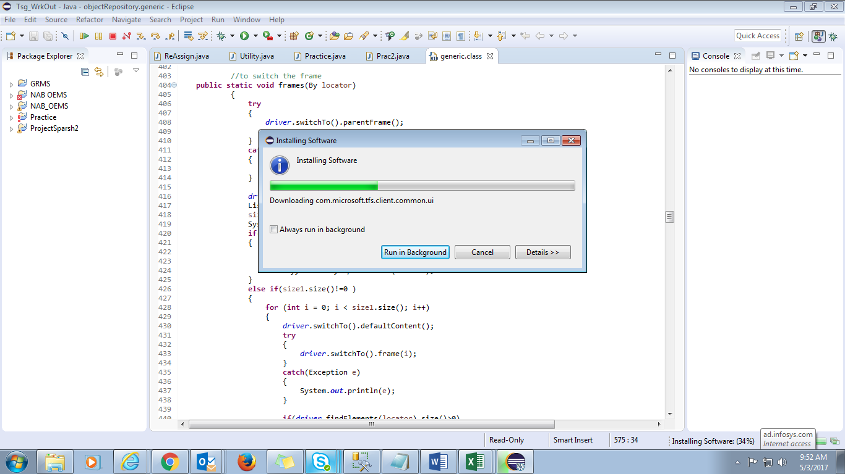

1. Restart the eclipse once the plugin is installed.

# Sharing Eclipse Projects in Team Foundation Server

To share your projects in Team Foundation Server:-

1. Open eclipse, in the package explorer, right click on the project that you want to add to version control, and choose **Team -> Share Project**

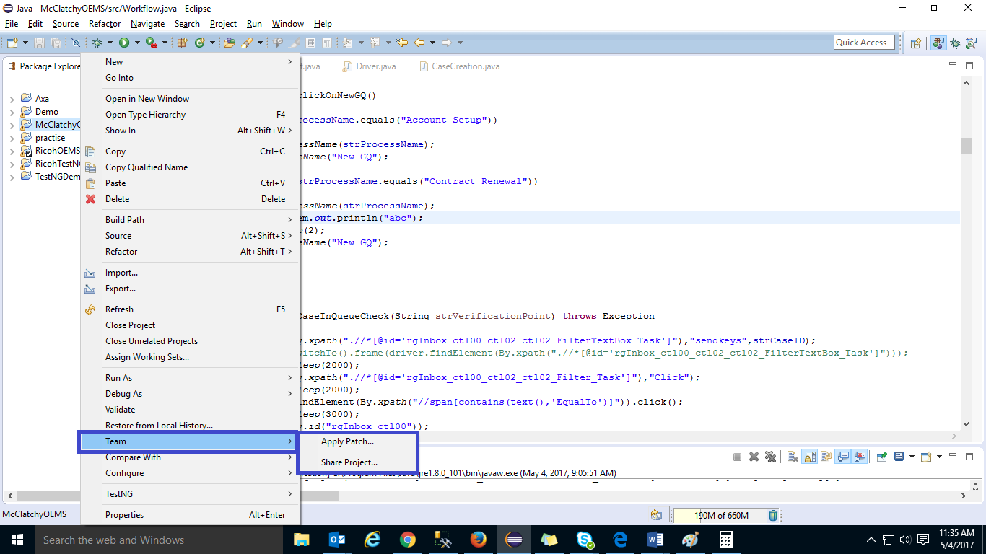

* 1. On click of Share Project, “**Share Project**” dialogue box will appear. Select Team Foundation Server and click on “**Next**”

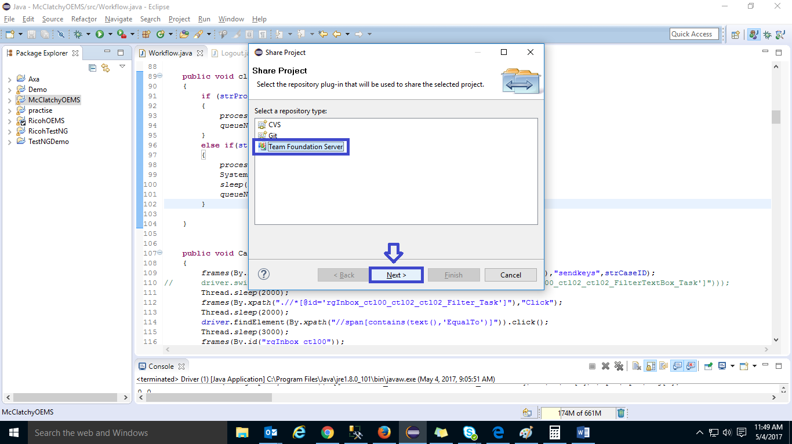

* 1. Click on the project Name and click on “**Next**”

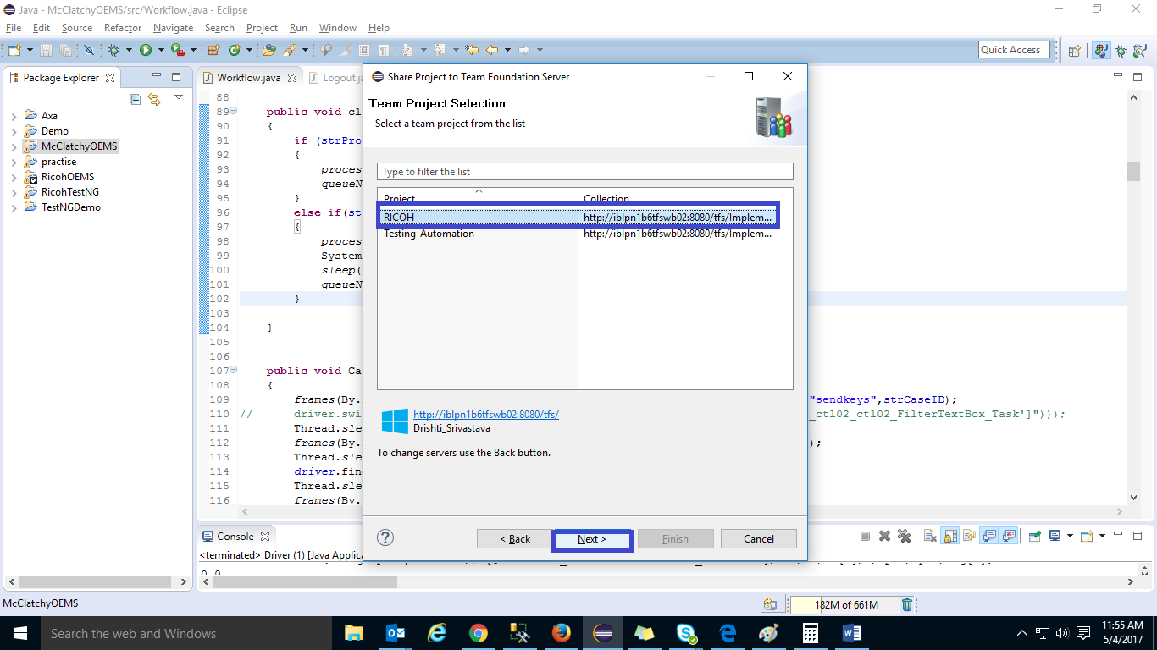

* 1. Select “**Test-Automation**” folder under the selected project. Click on “**Next**” and “**Finish**”

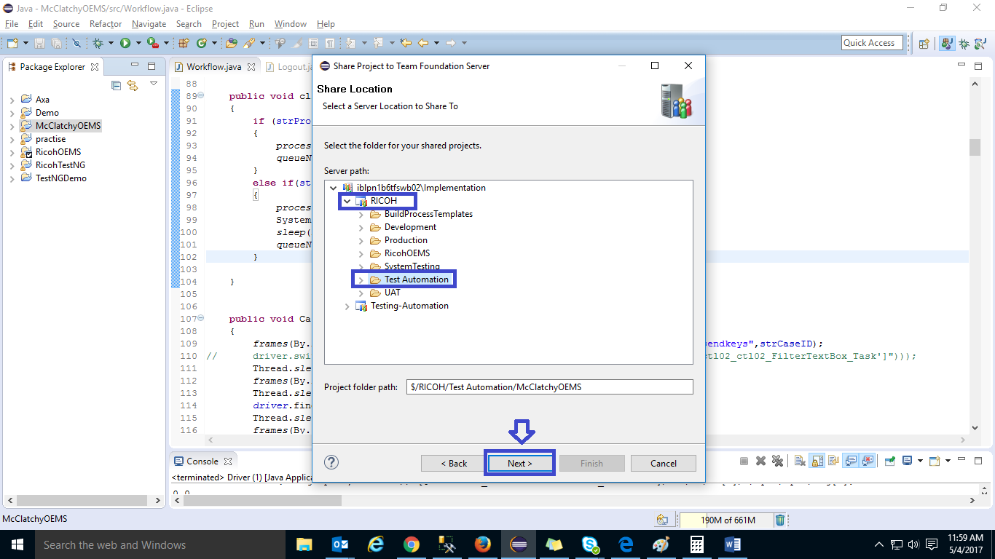

The project is now associated with the version of the project that is under version control in Team Foundation Server.

# Check the project in to TFS

By default, Team explorer does not appear. For checking the project in to TFS. Following important functions can be performed once your selenium scripts are integrated with TFS

* + Check IN Pending Changes
  + Check OUT for Edit
  + Get Latest Version

## **Check In Pending Changes:-**

When you check in files, the system commits pending changes in your workspace to the Team Foundation version control server.

1. Click on **Window -> Show View-> Other -> Team Foundation Server -> Team Explorer -> OK**

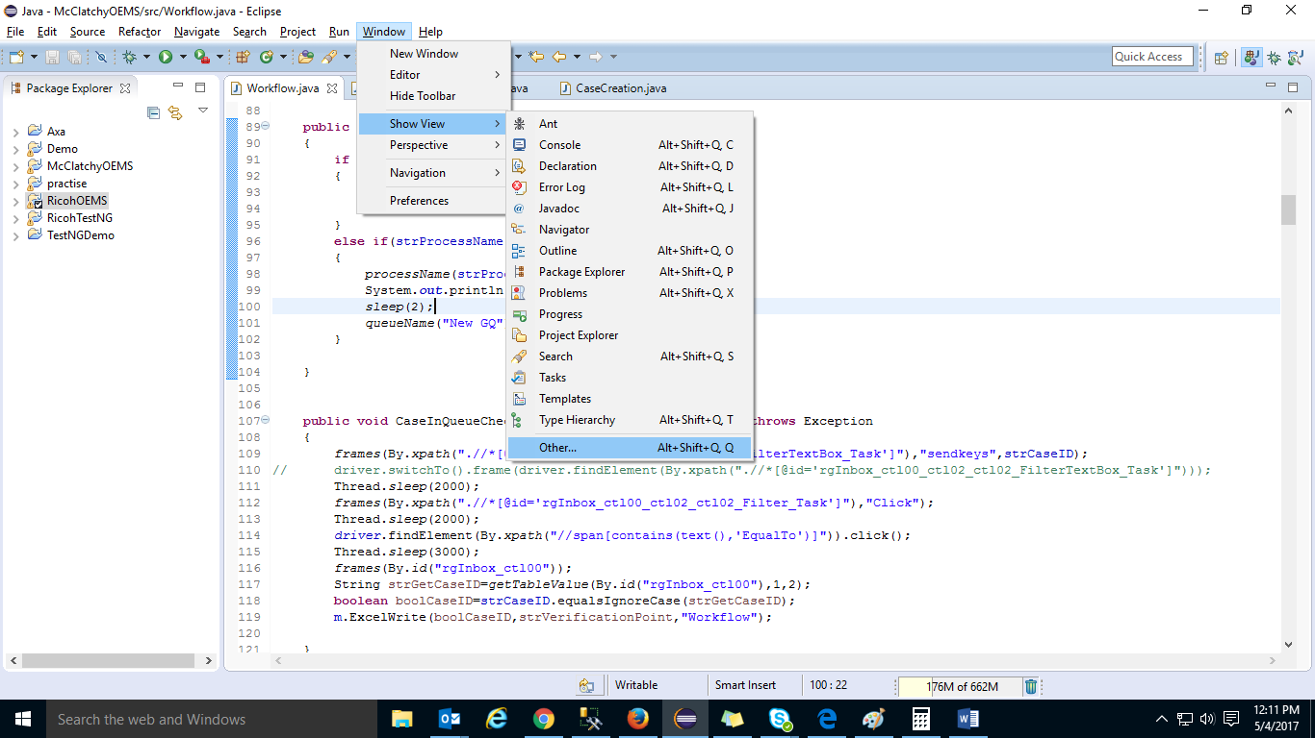

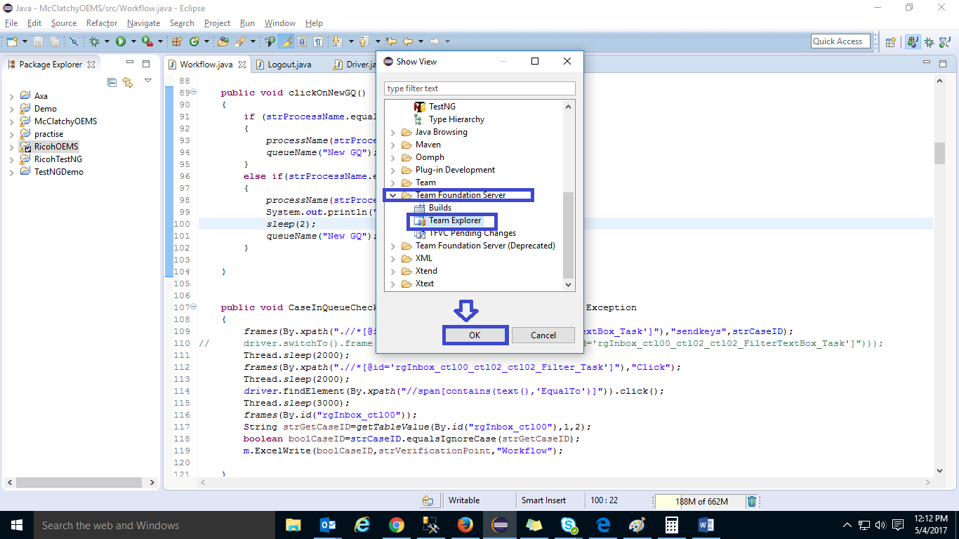

1. Once the “**Team Explorer**” window appears, click on **TFVC Pending changes -> Check In**

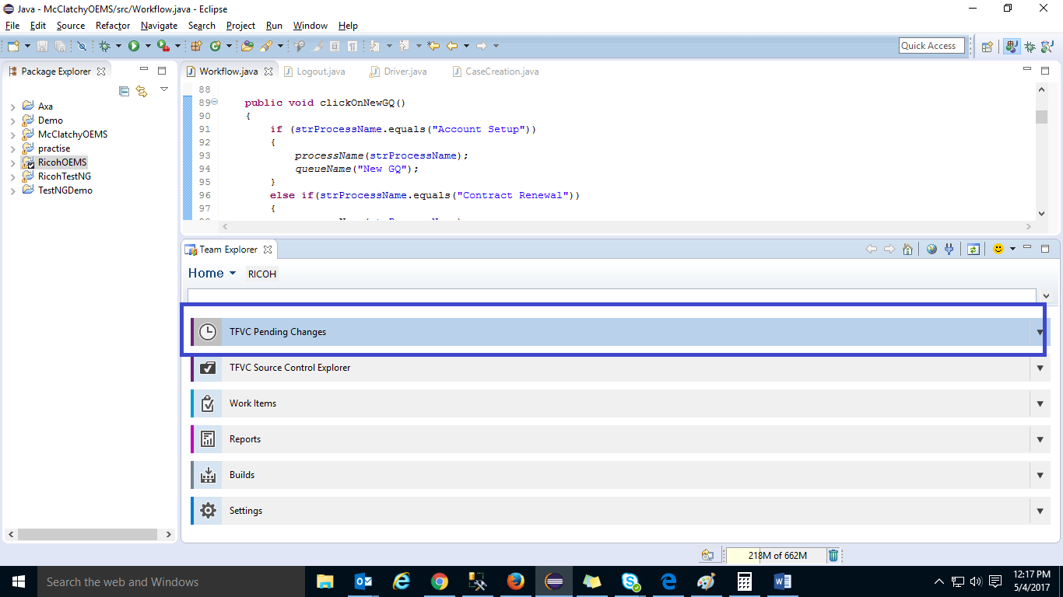

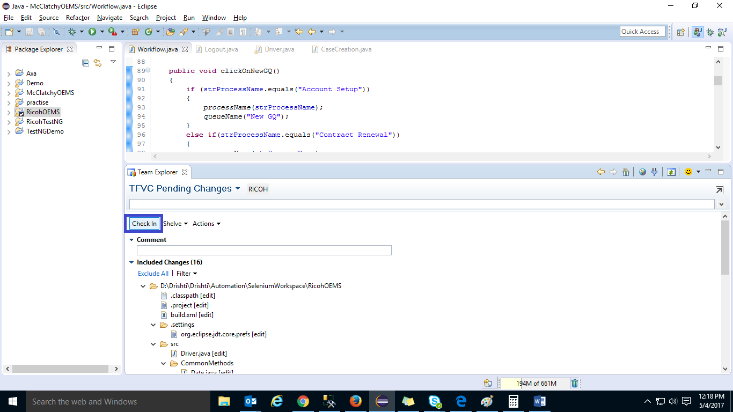

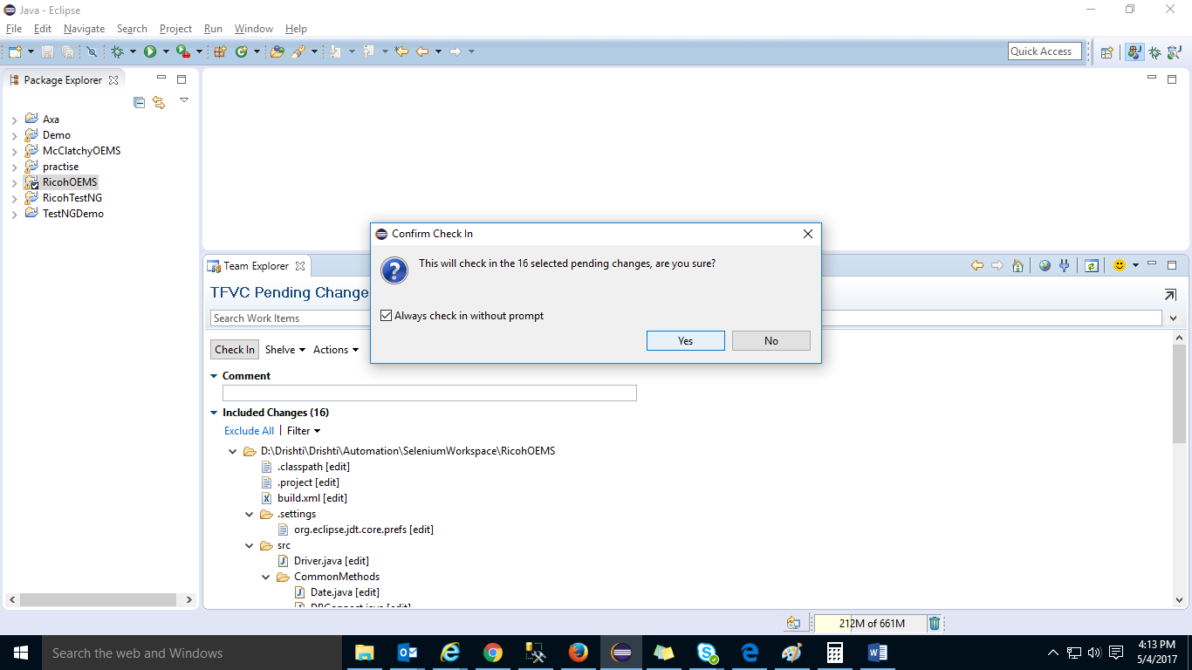

## **Check OUT for Edit:-**

Prevent other users from checking out and checking in the items until you check in and unlock them.

1. For Check Out, Right click on **project name -> Team -> Check Out for Edit**

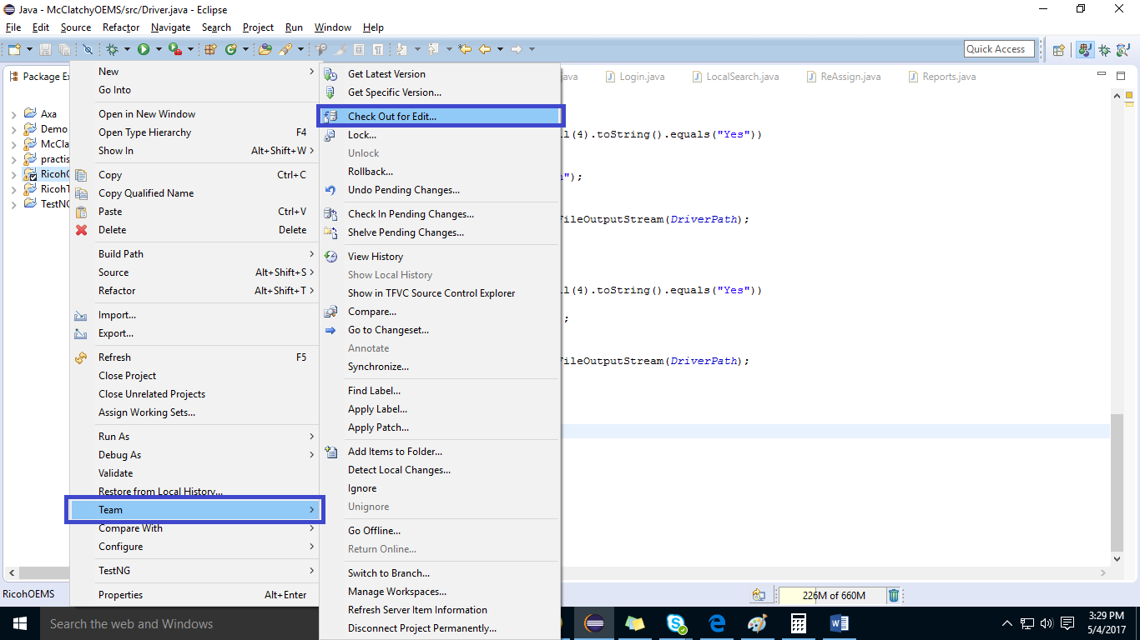

## **Get Latest Version:-**

As a general rule, you should get the latest versions of files from the server on a regular basis. Using the latest versions makes sure that the code you develop is compatible with the code developed by others on your team.

1. To get latest Version, Right click on **project name -> Team -> Get Latest Version**

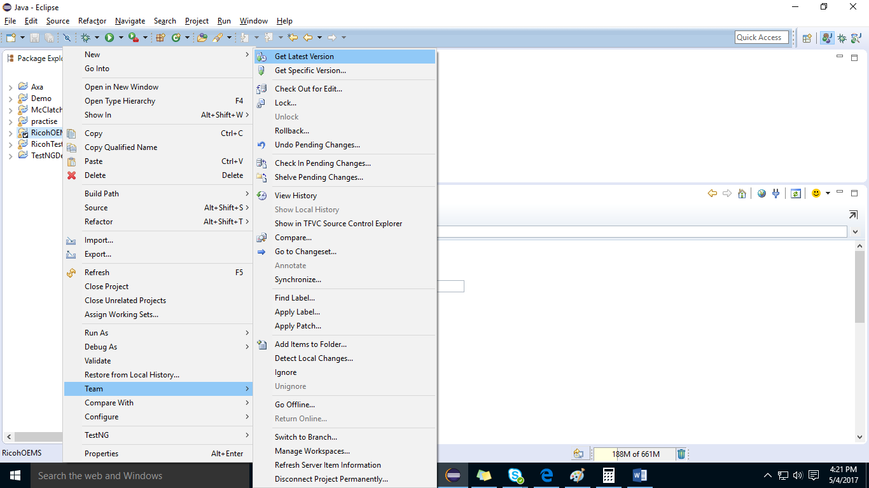

**Conclusion:-**

Once Your Eclipse is integrated with TFS, you can check in and check out the codes.

# Reference(s):

<https://msdn.microsoft.com/enus/library/hh301122(v=vs.120).aspx>